Header:
The Patient Portal is Open [will be on April 1]
Copy: [Pulled from Portal document]
Portal at a Glance
The new Patient Portal allows patients who seek treatment at any Florida Hospital to enroll during patient registration. Once this option is selected, the patient receives an invitation by email to subscribe. As a subscribed member, the patient will be able to view their online health summary, including things like allergies, medications, problems and lab results on file in Cerner.
**Doctor office notes are not part of the Health Summary that can be accessed by patients.

What’s My Role?
Beginning April 1, 2013, we encourage you to invite your patients to register for the Patient Portal. There is a new feature in the Cerner system for you to enter a patient’s email during your registration conversation. Once a patient is registered, an invitation will be sent to the provided e-mail address with specific enrollment instructions.
For patients who decide not to provide an email address at the time of their visit, but call back later and decide they would like to register for the Patient Portal, please follow the steps below.
- Open the Conversation Launcher
- Select “FHMG/Fri/FH Add/Modify Person” conversation
- Search for your patient
- Once you select the appropriate patient and the conversation opens flip the online access to “Yes” and enter their email address.
- Save your changes when exiting the conversation.

[We can link to more information on the intranet here – researching where this will be]

Subhead:
Physicians Spotlight

Copy:
Please welcome our newest physician as FHMG continues to grow and broaden its medical presence in Central Florida.
[Include headshot of physician]
Erin Best, MD, FACOG [Start date approved by Sheri on March 25, 2013/ Bio approved]
A Place for Women

Dr. Best is board certified in obstetrics and gynecology, a Fellow of the American Congress of Obstetrics and Gynecology, and completed residency training at Baylor College of Medicine, renowned for an outstanding obstetrics and gynecology program. She joined Dr. Lucinda Kjerulff and Dr. Jennifer Swaboda at A Place for Women on March 25, 2013. Her commitment to deliver personalized OB/GYN care to her patients out of her Celebration and Dr. Phillips locations is complemented by her advanced certifications and recognition in specialties such as minimally-invasive surgery, incontinence, prolapse, permanent birth control and overall sexual and reproductive health. 321.939.3553
Header:
Florida Urology Associates Opens New Location
Copy:
Florida Urology Associates (formerly known as Winter Park Urology) has recently opened a new location in Lake Mary to better serve residents of Central Florida with excellence in comprehensive urology care. Patients can visit Dr. Thomas Cangiano at 4106 West Lake Mary Boulevard, in Suite 330, every Friday from 8:30 am to 11:30 pm. 407.897.3499

Subhead:
The Menopause Center Is Now Accepting New Patients [Approved by Kim]
Copy:
As the only menopause center of its kind in Central Florida and a destination center for women’s care, The Menopause Center had recently reached their patient capacity. Thankfully, that’s all changed. We are happy to announce that with addition of Raquel Pitt, PA-C, Dr. Baill and her dedicated team are now accepting new patients. A board-certified physician assistant, Raquel’s special interests lie in well women care, contraception, cancer prevention and quality of life improvement. She is also fluent in conversational Spanish. The Menopause Center specializes in creating individualized treatment plans based on each woman’s unique history, gynecologic and menopausal symptoms. 407.646.7045.

[Customer Experience Corner]

Header:
ONE Big Thank You

Copy: [copy and image sent/approved by James]
On behalf of the Customer Experience Team, Zorayma and James would like to extend a sincere thank you to the following individuals for their support and participation in key components of the ONE training program design and creation.

[Pat, the graphic below is exactly what James Agee sent over, but Kim doesn’t think it looks good. Do you think you can make it look better? If not, just include the names in a columned list – names are typed out below the graphic.]


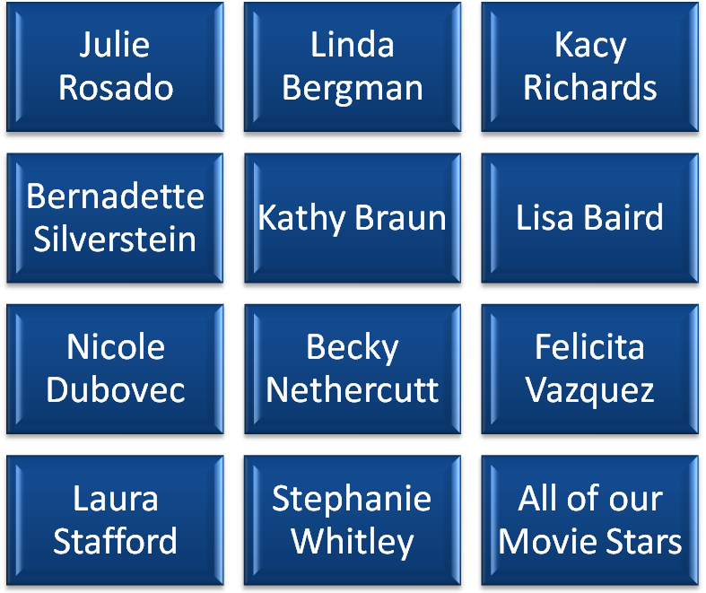

Our Sincerest Thank You

[list of names just in copy]
Julie Rosado
Linda Bergman
Kacy Richards
Bernadette Silverstein
Kathy Braun
Lisa Baird
Nicole Dubovec
Becky Nethercutt
Felicita Fazquez
Laura Stafford
Stephanie Whitley

